

**Green University of Bangladesh**

**Department of Computer Science and Engineering (CSE)**

**Faculty of Sciences and Engineering**

**Semester: (Fall, Year:2023), B.Sc. in CSE (Day)**

**Lab Report NO 1**

**Course Title: Software Testing & Quality Assurance Lab**

**Course Code: CSE 454 Section: D8**

**Lab Experiment Name: Introduction to Software Testing Environment of an E-Commerce Website.**

**Student Details**

|  |  |  |
| --- | --- | --- |
| **Name** | | **ID** |
| **1.** | **Md. Moshabbir Hossain Khan Emon** | **201002369** |

**Lab Date : 06/10/2023**

**Submission Date : 20/102323**

**Course Teacher’s Name : Montaser Abdul Quader**

|  |
| --- |
| **Lab Report Status**  **Marks: ………………………………… Signature:.....................**  **Comments:.............................................. Date:..............................** |

**1. TITLE OF THE LAB REPORT EXPERIMENT**

**Introduction to Software Testing Environment of an E-Commerce Website.**

**2. OBJECTIVES/AIM [2 marks]**

• To be familiar with software testing environment.

• To gain practical knowledge on how to set test environment.

**3. PROCEDURE / ANALYSIS / DESIGN [3 marks]**

Software Testing is the activity of checking whether the expected results match the actual results. It helps to ensure that the software system is defect free. It helps to identify missing requirements, gaps, or errors that might be contrary to the requirements. However, before testing a software you need to set up the testing environment.

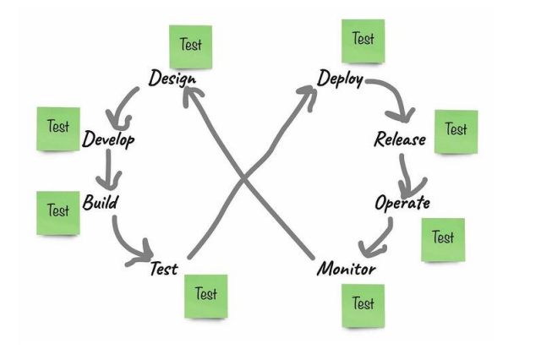

Figure 1: An example of continuous software testing

**4. TEST ENVIRONMENT MANAGEMENT**

* Environment Identification
* Environment Setup
* Data Management
* Version Control
* Environment Access Control
* Environment Monitoring
* Environment Maintenance
* Configuration Management
* Environment Cloning and Snapshotting
* Release Management:
* Collaboration and Communication
* Backup and Recovery
* Documentation and Training

**5. DESCRIBE THE PROCESS FOR SETUP OF SOFTWARE TEST ENVIRONMENT OF E COMMERCE PLANT WEBSITE**

**Environment Identification**

Identify the types of test environments required, such as development, staging, and user acceptance testing (UAT).

Determine the hardware and software requirements for each environment.

Allocate dedicated resources (servers, databases, etc.) for each environment.

**Hardware and Software Procurement**

Acquire the necessary hardware and software components, which may include servers, virtual machines, web servers, databases, and relevant licenses.

Ensure that the hardware and software meet the specifications and configurations required for the e-commerce plant website.

**Environment Design and Configuration**

Define the architecture and configuration for each environment, ensuring that they mirror the production environment as closely as possible.

Configure web servers, application servers, and databases with the required settings.

Install the e-commerce platform, web server software (e.g., Apache, Nginx), and application server software (e.g., Tomcat, Node.js).

**Data Management**

Create test databases with a subset of production data or synthetic data for testing purposes.

Implement a strategy for data anonymization if sensitive or personally identifiable information (PII) is involved.

Establish a process for data refresh to keep the test data current.

**Version Control**

Implement version control for application code and configurations.

Use a version control system (e.g., Git) to track changes in the codebase and configurations.

Ensure that the test environment always runs the appropriate version of the application for a given testing phase.

**Access Control**

Define and implement access control policies to restrict access to the test environments.

Use role-based access control to assign appropriate access levels to team members based on their responsibilities.

**Environment Documentation**

Document the configurations and settings of each environment, including server configurations and database schemas.

Maintain version history of configurations to track changes.

**Monitoring and Logging:**

Implement monitoring and logging tools to track the health and performance of the test environments.

Set up alerts for potential issues, such as resource utilization, system failures, or errors in the application.

**Test Data Preparation:**

Populate the test databases with sample data or relevant datasets for various test scenarios.

Ensure that the test data represents a variety of cases, including different products, user roles, and user behaviors.

**Test Environment Validation:**

Conduct initial tests to verify that the test environments are set up correctly and are ready for testing.

Verify that the e-commerce plant website is functioning as expected in the test environment.

**Test Environment Maintenance:**

Establish a schedule for regular maintenance activities, such as applying patches, updates, and security fixes.

Plan for periodic environment refreshes to keep the test data up to date.

**Release Management:**

Coordinate changes to the test environments with the release schedule to ensure that they match the target production state.

Consider automation for provisioning and managing test environments as part of a CI/CD pipeline.

**Collaboration and Training**

**6. ANALYSIS AND DISCUSSION [3 marks]**

The e-commerce plant website successfully passed the testing phase with no critical defects identified. It offers a robust and user-friendly platform for users to purchase plants and engage with the gardening community.